Answers

1. Add a column (Postal Code) to the Customer table and add some records to the column.

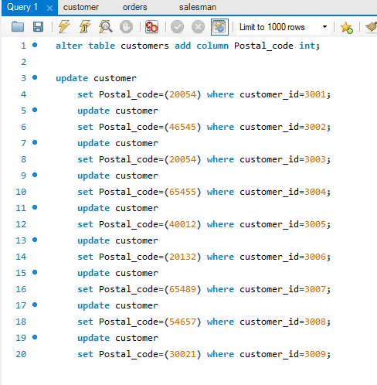

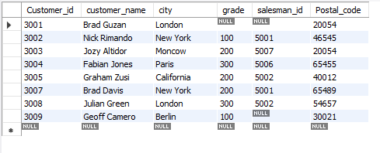

2. Retrieve salesman id of all salesmen from orders table without any repeats.

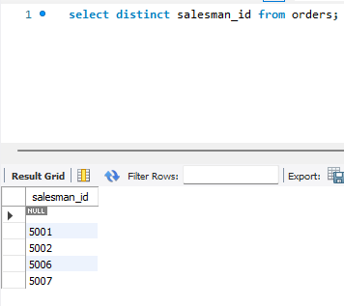

3. Display names and city of salesman, who belongs to the city of Paris.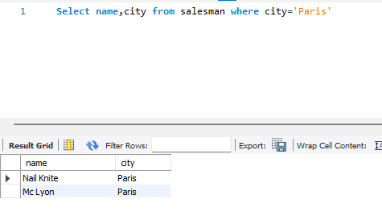

4. Display all the information for those customers with a grade of 200.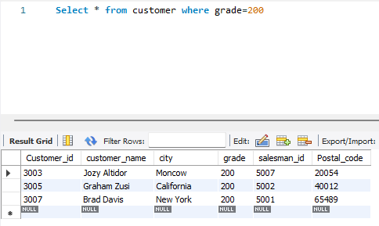

5. Display the order number, order date and the purchase amount for order(s) which will be delivered by the salesman with ID 5001

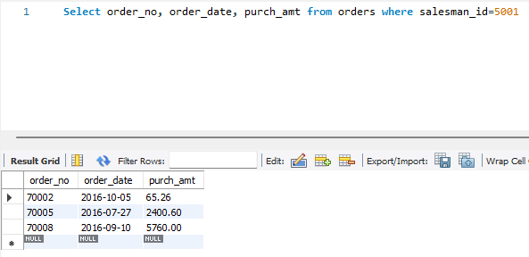

6. Show the winner of the 1971 prize for Literature.

7. Show all the winners in Physics for 1970 together with the winner of Economics for 1971.

8. Show all the winners of Nobel prize in the year 1970 except the subject Physiology and Economics.

9. Display all the customers, who are either belongs to the city New York or not had a grade above 100. 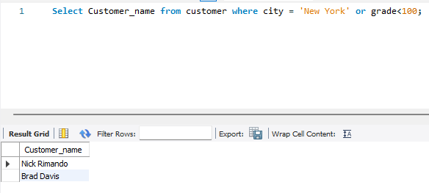

10. Find those salesmen with all information who gets the commission within a range of 0.10 and 0.12.

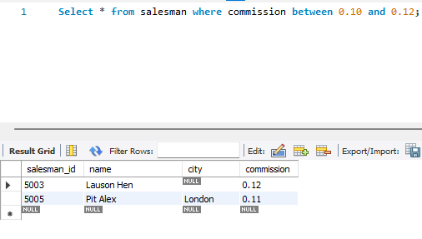

11. Find the total purchase amount of all orders.

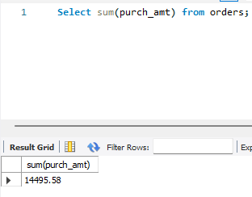

12. Find the number of salesman currently listing for all of their customers.

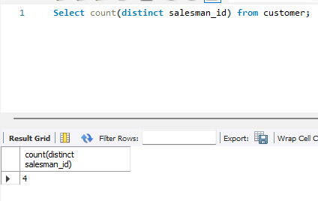

13. Find the highest grade for each of the cities of the customers.

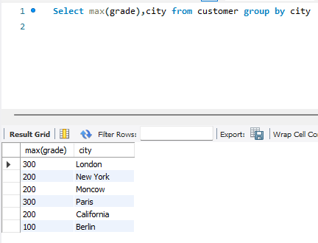

14. Find the highest purchase amount ordered by each customer with their ID and highest purchase amount.

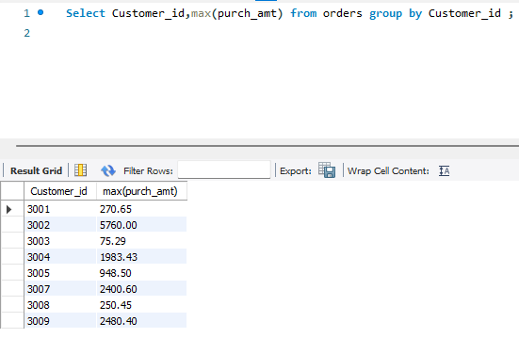

15. Find the highest purchase amount ordered by each customer on a particular date with

their ID, order date and highest purchase amount.

